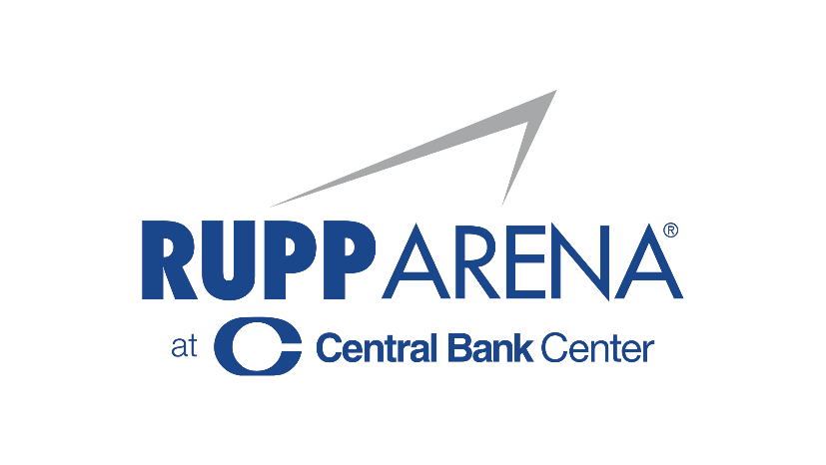

THE KID LAROI WILL BE AT RUPP ARENA ON SATURDAY, NOVEMBER 19th at 8:30 PM

ALSO FEATURING SPECIAL GUEST HENNESSY

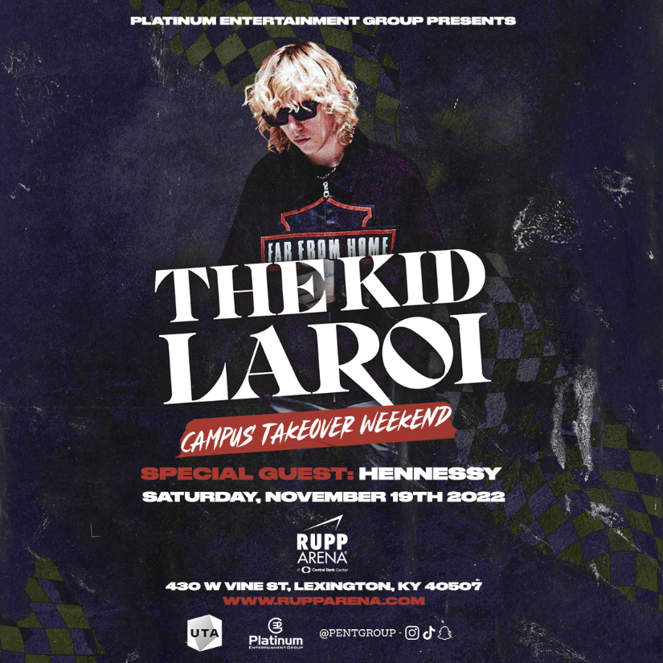

Lexington, Ky. (August 25, 2022) – Platinum Entertainment Group and OVG360 are excited to announce that The Kid LAROI is coming to Rupp Arena this fall. It’s not every day you meet a newly 18-year-old with the confidence to set his sights on rap royalty and the audacity to actually attempt it. Factor in that he’s from Australia, and The Kid LAROI’s rapid ascent seems even more unlikely. But, after just one #1 major label debut, a couple platinum records, and millions of streams across platforms, the rapper born Charlton is proving that for an incoming generation filled with promising talent, yesterday’s borders aren’t today’s barriers, and anyone can make it in America as a musician.
Born and raised in Sydney (aside from a short stint in the countryside) to a mother of Aboriginal descent and a French father, LAROI was raised by his mother and his uncle in a gritty environment. When they weren’t at The Fact Tree, a local youth center where they played video games and pool, LAROI and his friends were on the streets. “We used to just mess around,” he admits, describing his childhood unromantically. Meanwhile, the grown-ups did what they had to, outside the confines of the law, to provide for LAROI.
LAROI grew up consuming one of America’s most adored exports, listening to hip-hop and R&B icons like Tupac, Erykah Badu, The Fugees, Lil Wayne and Kanye West. He’s wanted to make music since he can remember, hoping to claim a spot within this specifically American legacy. LAROI started out writing raps as a kid, filling notebooks with rhymes and finessing his skill as a lyricist. But it wasn’t until he started uploading freestyle videos online that he began to find an audience for his stories and record his work. “A guy reached out to me on Facebook saying I could use his studio for free—he gave me a bunch of studio time, I made a whole bunch of songs and just posted them up on Soundcloud,” he remembers. Following the tragic murder of his uncle in 2015, LAROI and his mother struggled. They moved into project housing and below the poverty line. LAROI honed in on his music.
Not unusual for an 18-year-old, LAROI’s lyrics can be unrefined and audacious. The 2020 song “Without You” (the music video boasts over 71 million views), best demonstrates LAROI’s penchant for raw, at times crude, love stories. But his ear for infectious beats and melodic, gracefully structured hooks gained him the attention of the industry and acclaim from music’s most exciting voices. After competing in a Triple J Radio competition in 2016, he earned respect from industry execs, whose support led him to performances on stages alongside the late JuiceWRLD, whom he considered a close friend and mentor, THEY and more. In 2018, he recorded his debut EP 14 With A Dream executive produced by frequent collaborator Miracle, and watched standout “Blessings” take off. A well-timed freestyle over Drake’s Tay Keith-produced “Nonstop” added fuel to LAROI’s trailblazing fire.
“It’s really what I’ve always imagined... I always knew it was bigger than that,” LAROI says about his crossover success and finding an audience outside of Australia. With the newfound success from his most recent EP “F*CK LOVE 3 (OVER YOU)” (which also debuted #1 on the Billboard 200), this is just the beginning for LAROI. After spending 6 of its 17 weeks at no.1 on the Hot 100, the smash hit “Stay” is just a glimpse of what The Kid LAROI has coming. “I love everything I make. I take music super seriously, and I look at it as art,” says the teenage rap phenomenon. With an undeniable belief in his potential and the fast-paced track record to prove it, LAROI, unexpected as his story is, is making it increasingly easy for the rest of the world to believe in him too.
Tickets for The Kid LAROI’s “Campus Takeover Weekend” will go on-sale Friday, August 30th at noon local time. To purchase tickets visit www.rupparena.com.

Media Contact:
Rupp Arena Stephanie Bork sbork@centralbankcenter.com
# # #

About Central Bank Center
Located in Lexington, Kentucky, the Lexington Center Corporation (LCC) is a not-for-profit 501c3 corporate agency of the Lexington Fayette Urban County Government. It was established in 1974 to manage and maintain Rupp Arena at Central Bank Center, the Central Bank Center (formerly Lexington Convention Center), Triangle Park, and the Lexington Opera House. One of the nation’s most storied entertainment destinations, Central Bank Center venues collectively welcome an average of 1.3 million patrons annually.
Since 1976, Rupp Arena at Central Bank Center has served as the home court of the University of Kentucky men’s basketball team, regularly leading the national attendance average. Rupp Arena has hosted legendary artists such as Justin Timberlake, Paul McCartney, Garth Brooks, Chris Stapleton, and many more. Since 2018, Oak View Group and Live Nation Arenas have provided booking services to Rupp Arena. During the last 18 months, Rupp Arena has broken all previous audience attendance and revenue records in its storied 43-year history.
The Lexington Opera House, built in 1886 and listed on the National Register of Historic Places, is one of the premier performing arts centers in the region. Since its opening, the Opera House has played host to such famous stage performers as W.C. Fields, The Marx Brothers, Al Jolson, Julie Harris, Steve Martin, Brian Wilson, and Graham Nash. It has undergone two major renovations and remains a cultural destination in downtown Lexington.

The Central Bank Center holds over 200 meetings, trade shows, and special events annually. It just completed a transformative $310 million expansion, featuring a dramatic, light-filled architectural design that offers over 200,000 SF of flexible meeting and event space. For more, visit www.centralbankcenter.com or follow us on Facebook, Instagram, or Twitter.

About OVG360:
OVG360, a division of the Oak View Group, which was founded by Irving Azoff and Tim Leiweke and supported by Silverlake, specializes in event programming venue assessments and security and emergency preparedness. OVG360 can also provide full management services for arenas, stadiums, convention centers, and performing arts centers. Oak View Group is the largest developer of sports and entertainment facilities in the world with $4.5 billion of deployed capital across eight project

