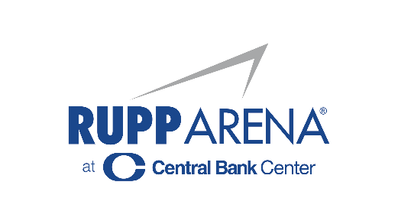

For Immediate Release

CHRIS TOMLIN & HILLSONG UNITED AT
RUPP ARENA ON NOVEMBER 4, 2022

“Tomlin UNITED Tour”

Ticket On-Sale Begins Thursday, September 1
Sign Up Now for Exclusive Pre-Sale at TomlinUNITED.com

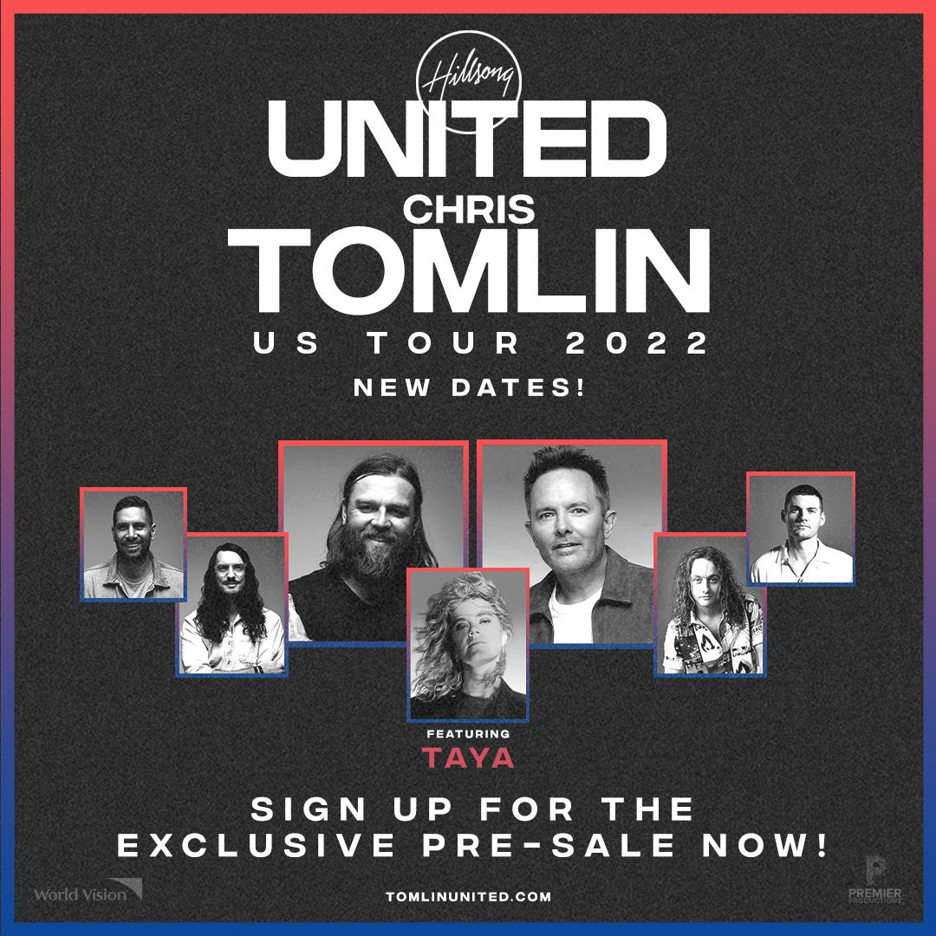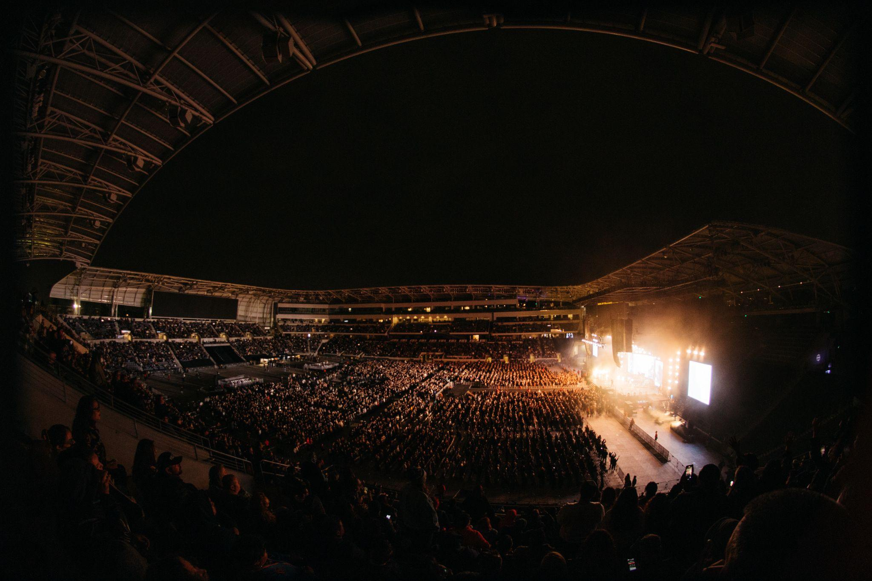
photo by Nolan Knight

Watch highlights from the tour HERE

Lexington, KY – (August 26, 2022) – On the heels of their highly successful 22-city “Tomlin UNITED Tour” out earlier this year, the multi-platinum selling and multi-award-winning artists Chris Tomlin and UNITED are announcing the addition of a third leg coming this fall. The tour, named by Pollstar as a ‘Top 10 Worldwide Tour,’ will continue to welcome thousands of worshippers each night as one of the biggest Christian concert events continues with dates beginning November 3. Tickets for the “Tomlin UNITED Tour” will go on sale Thursday, September 1 at TomlinUNITED.com. Patrons can sign up now for the pre-sale at TomlinUNITED.com
“Something powerful happens when we come together, all the streams of the church, to worship in Unity and One voice… it’s more than a concert, it’s an opportunity for us to join in the eternal praise,” shared Chris. “My prayer and belief for these nights with United is that everyone in the building, myself, the attendees, the musicians, the crew, each person working at the venue - everyone - is met by God right where they are in life and has an encounter that reminds us of the hope we all have in Him.”
“In light of what our world has collectively been through in the last couple of years and the journey we have personally been through, being able to gather and worship together has been something that has brought much joy and encouragement,” shared Jonathon Douglass of UNITED. “That’s why we are so looking forward to continuing the journey of this tour to share and experience who God is and how he is present with each and every one of us right now! We look forward with great expectation to these nights with a great faith that God is going to move in our lives and bring joy and encouragement personally to everyone who joins with us!”
The fall leg will visit a dozen major cities across the U.S. including St. Louis, Seattle, Salt Lake City, Indianapolis, Charlotte and more. Music critics claimed the “Tomlin UNITED Tour” was ‘more than a concert- it was a worship experience for the performers and audience’ and ‘many were so overcome by the music they were brought to tears. The outpouring of emotion was awesome to witness.’

With a combined hope that this tour will help reunite the church, Tomlin and UNITED remained focused on launching the tour throughout an 18-month delay due to the COVID-19 pandemic. Premier Productions is the national tour promoter and World Vision will serve as the tour sponsor.

On September 9, Chris will release his next full-length project, Always. The title track was released to Christian radio this spring and made its live debut on the “Tomlin UNITED Tour” earlier this year. The official live video for “Always” was filmed live from Chris’ annual “Good Friday Nashville” concert event and premiered exclusively with Facebook.

UNITED released their new full-length studio album earlier this spring, Are We There Yet?

“Tomlin UNITED Tour”
11-3 Knoxville, TN Thompson-Boling Arena
11-4 Lexington, KY Rupp Arena
11-5 St. Louis, MO Chaifetz Arena
11-9 Seattle, WA Angel of the Winds Arena
11-10 Boise, ID ExtraMile Arena
11-11 Salt Lake City, UT Maverick Center
11-12 Loveland, CO Budweiser Events Center
11-14 Tulsa, OK BOK Center
11-15 Wichita, KS INTRUST Bank Arena
11-16 Des Moines, IA Wells Fargo Arena
11-18 Indianapolis, IN Gainbridge Fieldhouse
11-20 Charlotte, NC Spectrum Center

About Chris Tomlin
TIME magazine heralded Chris Tomlin as the “most often sung artist in the world” as his music has inspired and uplifted an entire generation of believers. Along the way, Chris has scored 17 #1 one singles at radio, placed 29 top ten hits (more than any other Christian artist), sold more than nine million albums with 5.6 Billion career global streams, earned a Grammy, three Billboard Music Awards, 27 Dove Awards, became a two-time BMI Songwriter of the Year honoree and an ASCAP Songwriter of the Year. In 2016, he was named one of only four artists ever to receive the Sound Exchange Digital Radio Award for over 1 Billion digital radio streams, alongside Justin Timberlake, Pitbull and Garth Brooks. Chris is also the first Christian artist to reach the Billion streams threshold on Pandora and was presented with their BILLIONAIRE award. As one of the most successful Christian touring artists today, Chris has sold-out venues everywhere including New York City’s Madison Square Garden, the Hollywood Bowl in Los Angeles, Nashville’s Bridgestone Arena, Red Rocks in Denver and more. Chris recently set a career attendance record with an unprecedented concert at LA’s Banc of California Stadium.

For more information:
go to www.christomlin.com or follow him - Twitter Instagram Facebook and YouTube.

About UNITED
UNITED is a multi-award-winning, platinum-selling artist whose chart successes (repeatedly no. 1 on Billboard’s Christian charts and up to #5 on Billboard 200) are only bested by the millions of lives they’ve impacted across the globe. Reporting over 50 million people singing from the Hillsong catalogue songs every Sunday, the modest band born from a youth ministry out of Hillsong Church in Australia, touts a reach of over 10 million across all major social network platforms to date, including 2.1 billion minutes garnered from YouTube viewers. Comprised of an evolving, eclectic mix of musicians and songwriters, the band is led by Joel Houston and Taya, names that have become synonymous with Christian radio, dominating airwaves with every new release. Their last four studio albums have each topped the USA Christian chart, with “Zion” and “Empires” charting no. 1 (“Zion” recently also went Gold in the US); “Oceans,” written by Houston and band member Matt Crocker recently went triple platinum in the States, counting 200+ million streams and reigning on top of the Christian songs chart for a record 54 weeks.

In studio, on tour or at home, UNITED is committed to writing songs that speak truth, create a unique sound and connect people everywhere with God, evident by the success they’ve seen globally. With over 50 countries and six continents visited, UNITED continues to sell out arenas and stadiums around the world, including sold-out nights at the Forum, STAPLES Center and The Hollywood Bowl in Los Angeles, The Toyota Center, Oracle Arena, Air Canada Arena, American Airlines Arena (Miami and Dallas), and Red Rocks to scratch the surface. UNITED functions from the deep understanding that everything they do is an expression of a really extraordinary God doing what only He can do, through really ordinary people.
About Premier Productions:
Founded in 1996, Premier Productions has been a top 20 global promoter selling over 20 million tickets. Pollstar named Premier the #1 faith and family independent promoter in the last 10 years. Producing events that move the soul both nationally and internationally, Premier is proud to have helped raise more than $271 million to improve the lives of children and communities in 100+ countries worldwide. Whether it’s a large multi-day festival, sold-out concert or intimate conference, Premier seeks to positively impact the lives of every attendee so they leave encouraged, happy and hopeful. Premier is currently promoting acts including Hillsong UNITED, Dude Perfect, Lauren Daigle, Hillsong Worship, Baby Shark, Blippi, Casting Crowns, Chris Tomlin, Elevation Worship, Kari Jobe, Wheel of Fortune Live, Spy Ninjas Live & more.
About World Vision
World Vision is a Christian humanitarian organization conducting relief, development, and advocacy activities in its work with children, families, and their communities in nearly 100 countries to help them reach their full potential by tackling the causes of poverty and injustice. World Vision serves all people regardless of religion, race, ethnicity, or gender. For more information, please visit worldvision.org

Contact:
Jessie Schmidt
Jessie@schmidtpr.com
615-491-7988

# # #

About Central Bank Center
Located in Lexington, Kentucky, the Lexington Center Corporation (LCC) is a not-for-profit 501c3 corporate agency of the Lexington Fayette Urban County Government. It was established in 1974 to manage and maintain Rupp Arena at Central Bank Center, the Central Bank Center (formerly Lexington Convention Center), Triangle Park, and the Lexington Opera House. One of the nation’s most storied entertainment destinations, Central Bank Center venues collectively welcome an average of 1.3 million patrons annually.
Since 1976, Rupp Arena at Central Bank Center has served as the home court of the University of Kentucky men’s basketball team, regularly leading the national attendance average. Rupp Arena has hosted legendary artists such as Justin Timberlake, Paul McCartney, Garth Brooks, Chris Stapleton, and many more. Since 2018, Oak View Group and Live Nation Arenas have provided booking services to Rupp Arena. During the last 18 months, Rupp Arena has broken all previous audience attendance and revenue records in its storied 43-year history.
The Lexington Opera House, built in 1886 and listed on the National Register of Historic Places, is one of the premier performing arts centers in the region. Since its opening, the Opera House has played host to such famous stage performers as W.C. Fields, The Marx Brothers, Al Jolson, Julie Harris, Steve Martin, Brian Wilson, and Graham Nash. It has undergone two major renovations and remains a cultural destination in downtown Lexington.

The Central Bank Center holds over 200 meetings, trade shows, and special events annually. It just completed a transformative $310 million expansion, featuring a dramatic, light-filled architectural design that offers over 200,000 SF of flexible meeting and event space. For more, visit www.centralbankcenter.com or follow us on Facebook, Instagram, or Twitter.

About OVG360:
OVG360, a division of the Oak View Group, which was founded by Irving Azoff and Tim Leiweke and supported by Silverlake, specializes in event programming venue assessments and security and emergency preparedness. OVG360 can also provide full management services for arenas, stadiums, convention centers, and performing arts centers. Oak View Group is the largest developer of sports and entertainment facilities in the world with $4.5 billion of deployed capital across eight project

